MARXIAN THEORY OF STATE

BONTI HAZARIKA
M.N.C BALIKA MAHAVIDYALAYA
NALBARI

“The state is a community of persons, more or less numerous, permanently occupying a definite portion of territory independent or merely so of external control and possessing an organised government to which greater body of inhabitants render habitual obedience”
James Wilford Garner
Marxian Theory
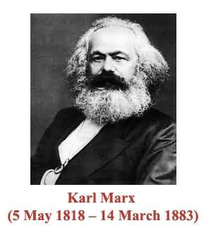
➢The Marxian theory holds that the state is not a natural institution.
➢The state is an instrument of exploitation in the hands of the propertied class.
➢The primitive society was a classless society. All natural resources were controlled by the people.
➢There was no exploitation and no political institutions existed at this stage.
➢In course of time due to the emergence of the institution of property, the society got divided into two antagonistic classes – the rich and the poor.
➢ The need for the state was felt to safeguard the interests of the propertied class.
➢The state is nothing but an instrument of the dominant class to maintain their economic and political supremacy.
➢To Frederick Engels, the division of labour at a certain stage of development led to the creation of the state.
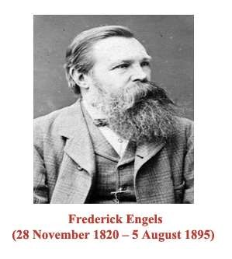
- In the lowest stage, men produced for their direct needs.
- In the middle stage, the pastoral people had in their cattle a form of private property. A kind of division of labour existed between the pastoral people and backward tribes without herds.
- In the upper stage, there was a further division of labour between agriculture and handicrafts.
- With civilization, there was a contrast between town and country.
- Classes were connected with production – managers and workers.
➢The state therefore came into being when the society got divided into two antagonistic classes.
➢The state belongs to the economically and politically dominant class which exploits the oppressed class.
- The state of slave owners holding down the slaves.
- The nobility in the feudal state holding down the serfs.
- The modern representative state is an instrument of exploitation of wage labour by capital.
- In Athens and Rome, rights were granted according to property.
- In the feudal system, power was determined by the amount of land owned by a person.
- In the early bourgeois state, the right to vote was granted on the basis of property.
- Today wealth may be used to corrupt bureaucracy or to forge an alliance between the ruling political party and the forces of capital.
➢To Lenin, the state is a product of class antagonism.
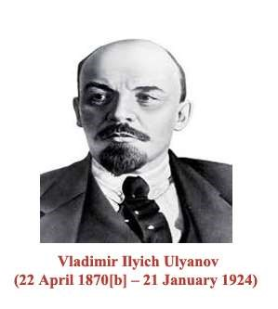
- The state is above society and is distancing itself more and more from it.
- A violent revolution is needed to destroy the state which was created by the ruling class.
- After the revolution the dictatorship of the proletariat will be established and will build a new social and economic order.
- ➢Engels maintains that the state will wither away after the dictatorship of the proletariat.
➢Only after the abolition of the classes the state shall start representing the interests of the whole society.
BASIC FEATURES OF MARXIAN THEORY OF STATE:
  - The state is not a natural institution.
  - The state was created by the propertied class to safeguard their interests.
  - The state is a class institution.
  - The state is an instrument of exploitation of one class by another.
  - The state is based on force – the dominant class uses all types of instruments to exploit and suppress the dependent class.
  - The state shall wither away after the proletariat has demolished the capitalist system.
  - A classless society makes its appearance.

CRITICISMS:
- It would be wrong to treat the state merely as an instrument of exploitation. The disappearance of the state shall lead to anarchy and chaos.
- The Marxian theory assumes that the state shall be retained by the proletariat for a while. This seems unlikely as the proletariat rulers are not likely to give up their power.
- The origin of the state is quite a complex process which cannot be explained merely by linking it with the origin of private property.
- The Marxists held that the state is merely an expression of the will of the dominant class. With the capitalist state assuming welfare character, the class character of the state has undergone a change.
- The character of capitalism itself has undergone a fundamental transformation since the times of Marx.
- There is an increasing replacement of individual ownership by corporate ownership.
- Shift of power from the owners of industry to the professional, managerial class and the technocrats.
- The adoption of the welfare state is bridging the gap between the rich and the poor.

Thank You

