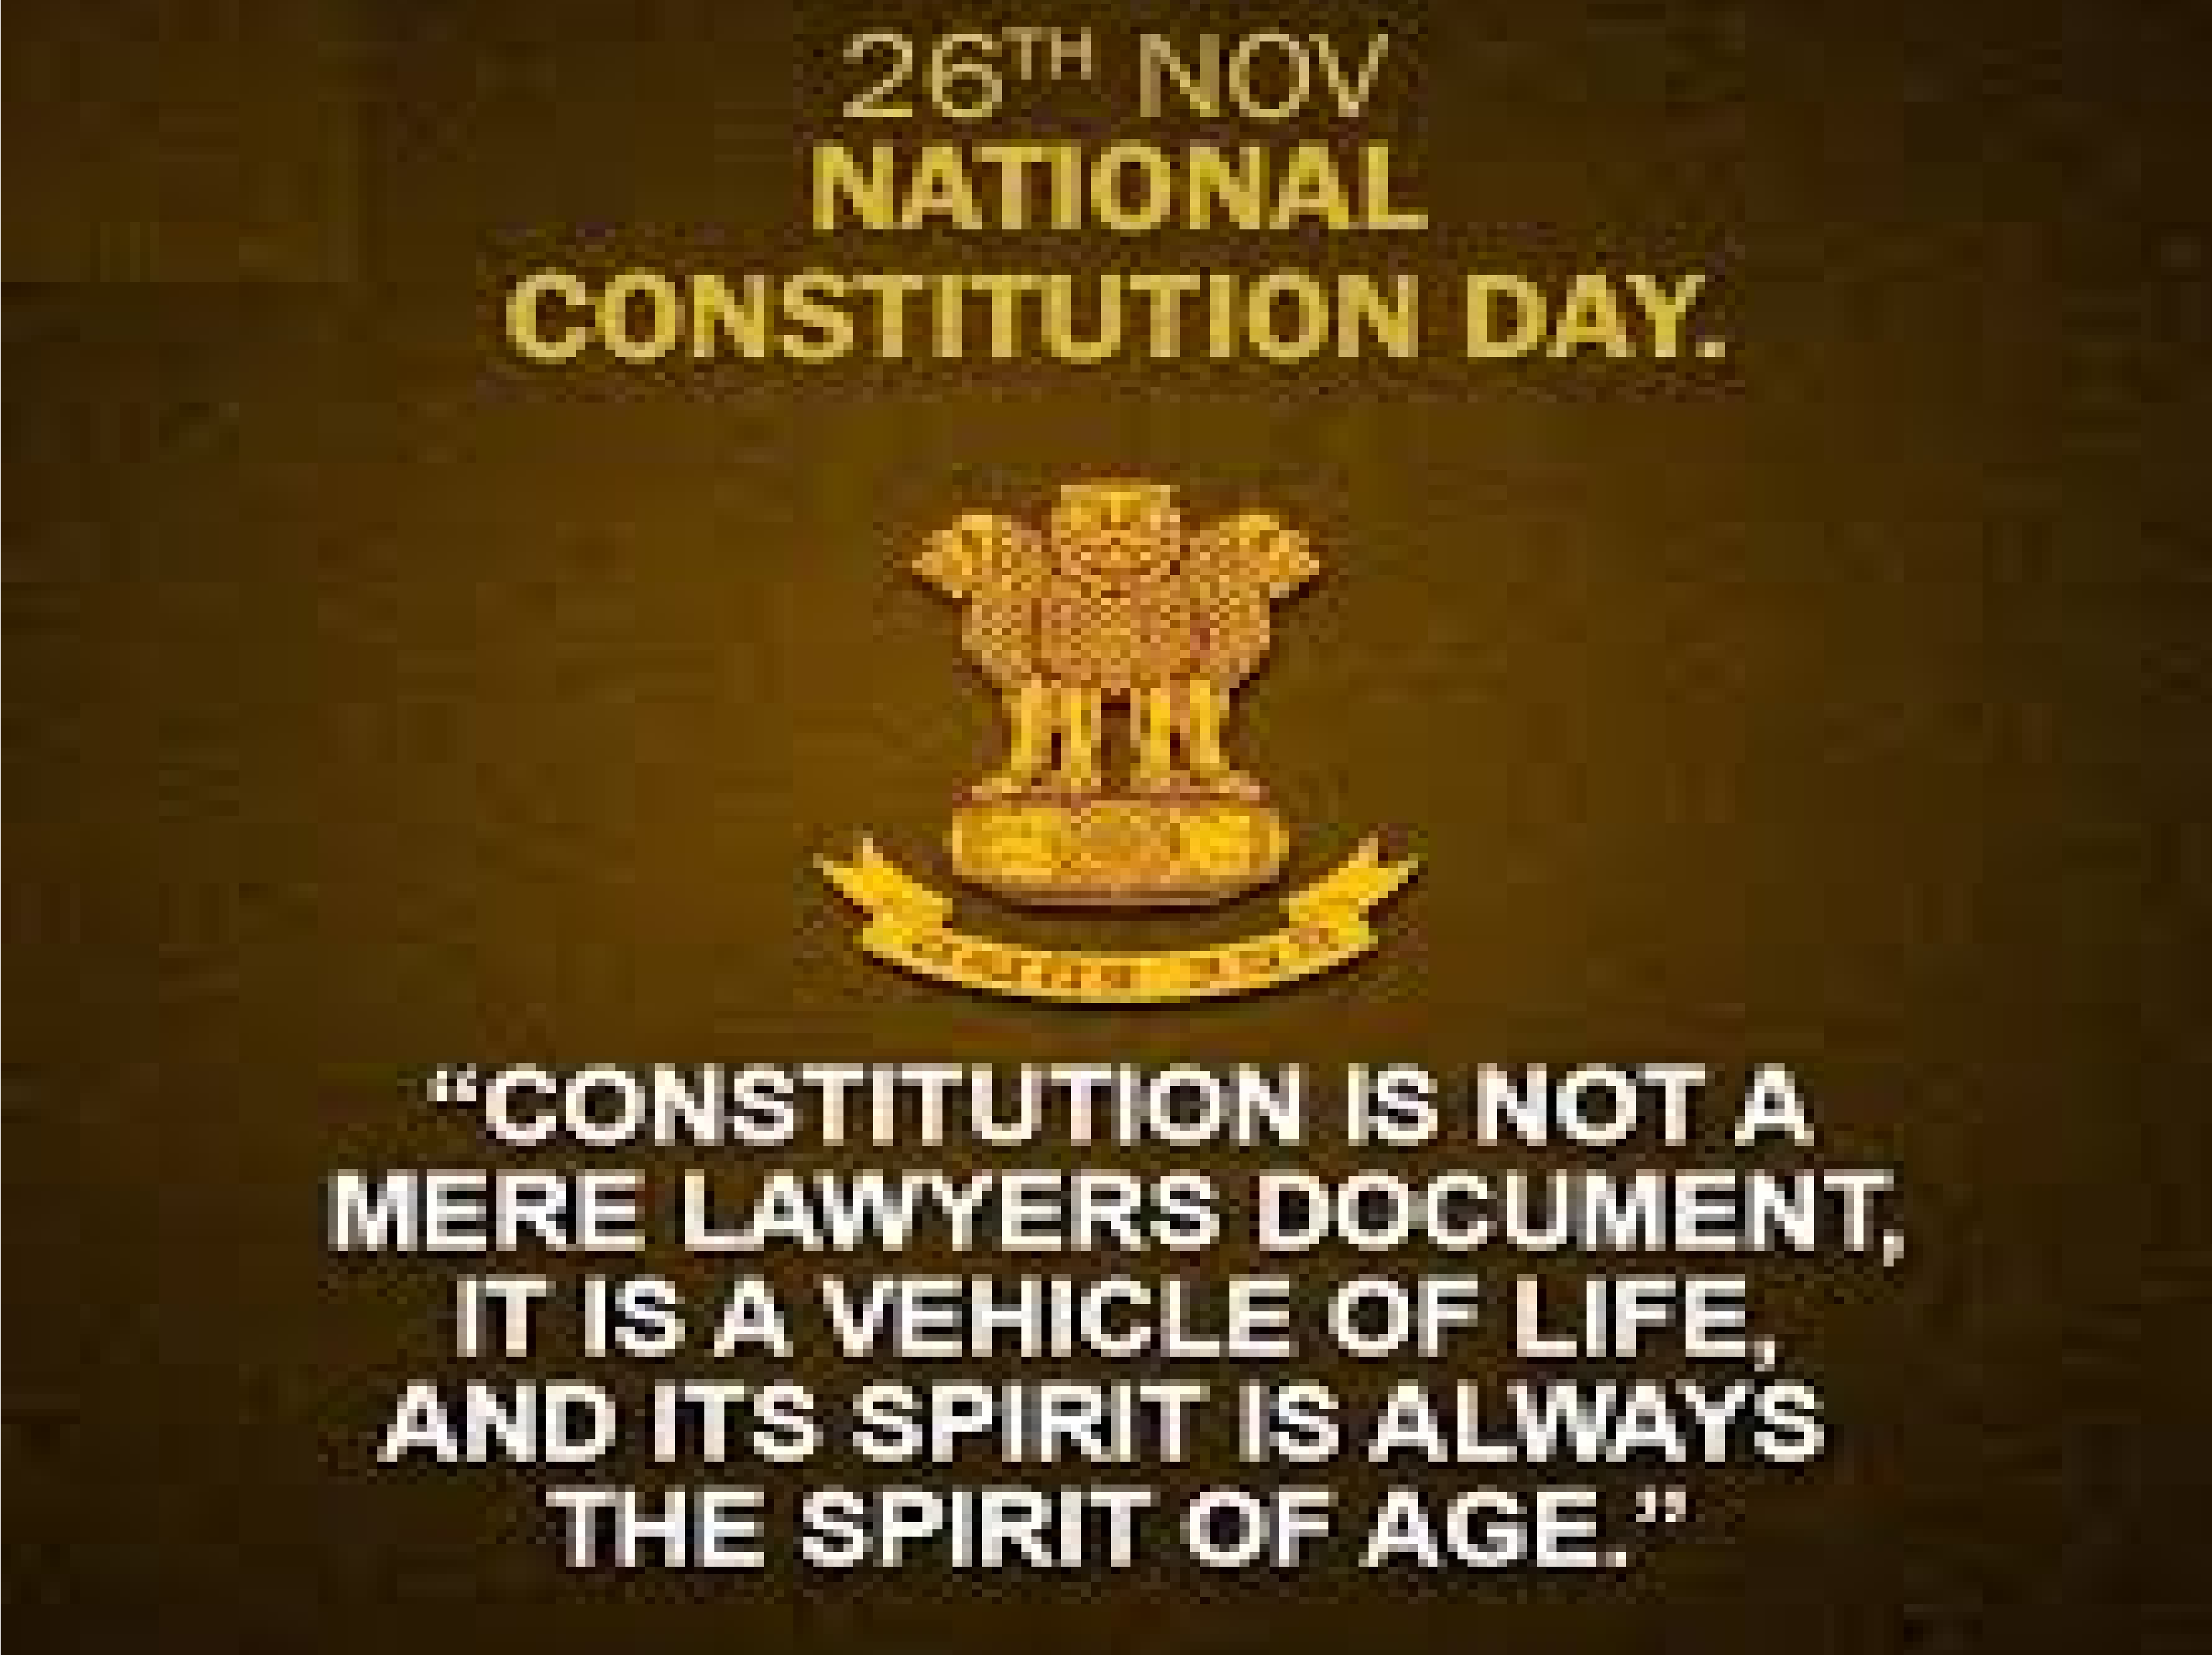
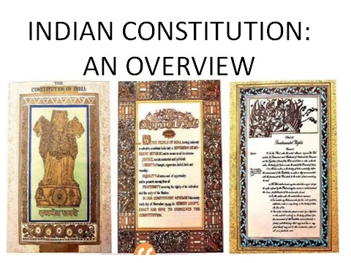
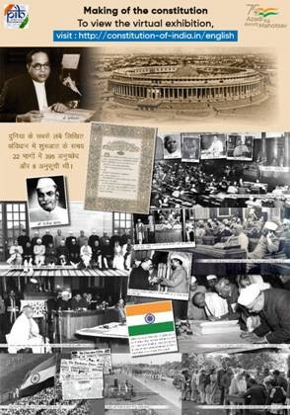

FRAMING OF THE INDIAN
CONSTITUTION

Freedom struggle movement
- Demand of Constitution
- In 1934 the idea of a Constituent Assembly was put forward by MN Roy.
- In 1935, the Indian National Congress (INC) for the first time, officially demanded a Constituent Assembly to frame the Constitution of India.
- In 1938, Jawaharlal Nehru, on behalf of the INC declared that the Constitution of free India must be framed, without outside interference
- The demand was finally accepted by the British Government and in 1942 sir Stafford Cripps, a member of the cabinet came to India with a draft proposal of the British Government on the framing of an independent constitution. The proposal was rejected by Muslim League.

- CAacbcoinret Mission wa…su e.s.ne tn At tsos eInmdbialy. was dingly, Constit
constituted and its first meeting held on 9t_{h} Dec, 1946
- Nehru on Dec 13, 1946 moved the historic Objective Resolution in the Assembly. It laid the fundamental and philosophy of the Constitutional structure.
- Formation of Drafting Committee
- Impact of Foreign Constitutions

On 26t_{h} November, 1949 Constitution of
India adopted

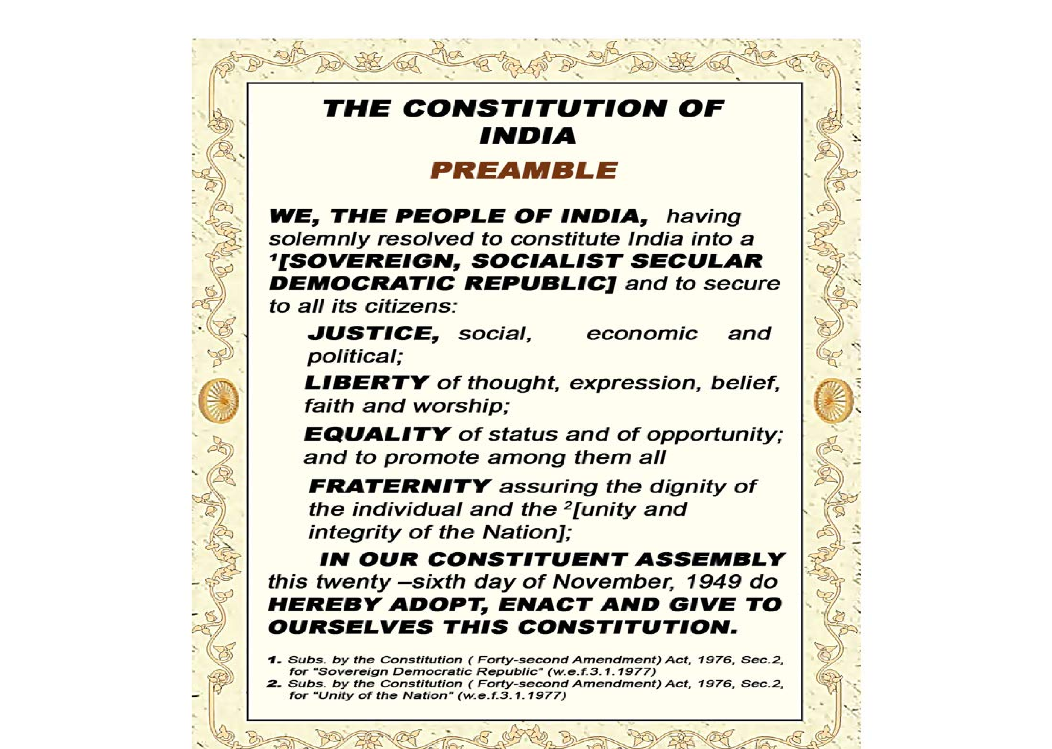
Preamble of the Indian Constitution

Fundamental Rights (Article 12-35)
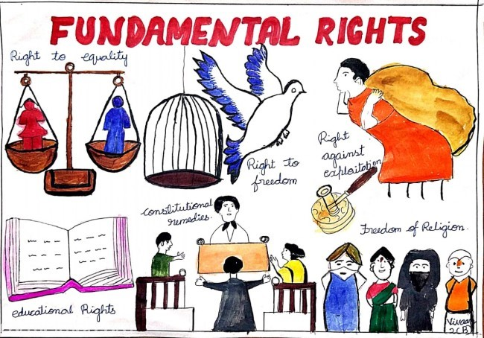

Rights to Equality (14-18)

Rights to liberty (Article 19-22)

(Article 23-24)
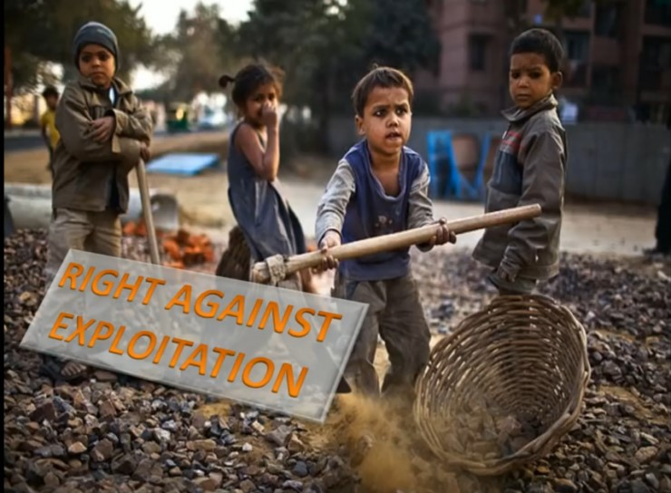

Article (25-28)

Article 29-30

Article 32
Directive Principle of State Policy
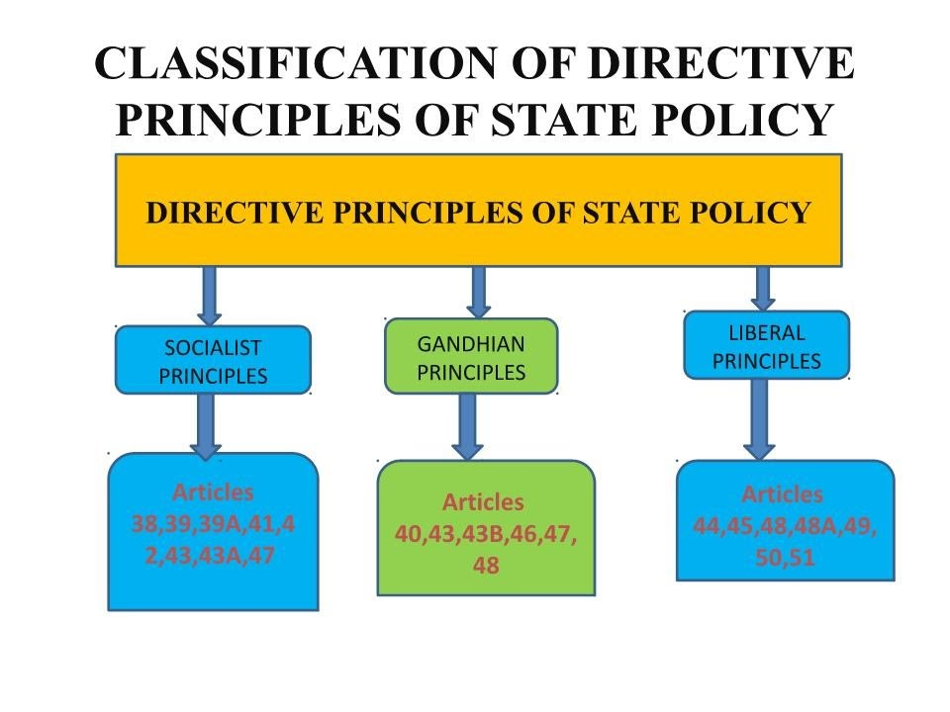
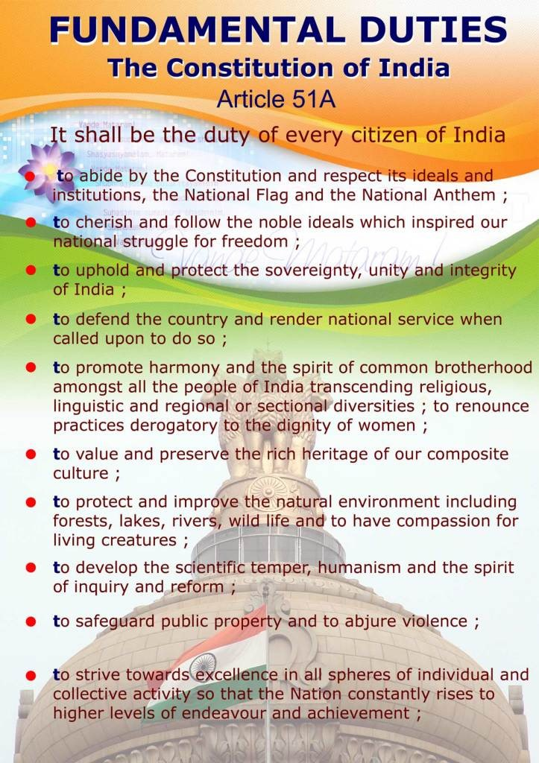
In 2002 by 86th
Constitutional amendments, last duty included in the list i.e. Duty to all parents to send their children in
the age group of 6-14 years to school.
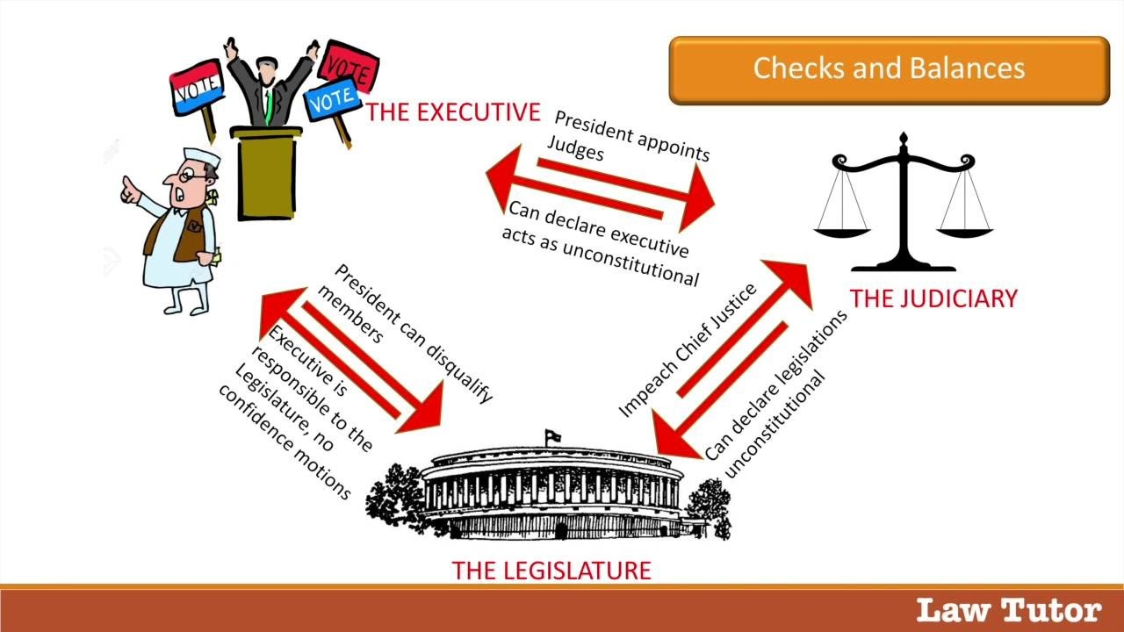
Structure of the Government

•
•
•
E
x
e
c
u
t
i
v
e

L
e
g
i
s
l
a
t
u
r
e

J
u
d
i
c
i
a
r
y

Decentralization
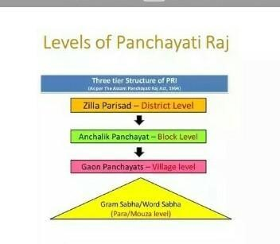
Federal nature of the Indian
Constitution
- Written Constitution
- Dual government
- Division of power
- Independent judiciary
- Bicameral legislature

Unitary nature of the Indian
Constitution
- Strong center
- Single constitution
- Single citizenship
- Emergency provisions

ARTICLES : 448 PARTS : 25
SCHEDULES :12 ……

PROUD TO BE AN INDIAN

JAI HIND
BONTI HAZARIKA
M.N.C. BALIKA MAHAVIDYALAYA, NALBARI

